

“6 Problem Solutions
And
Complexity Analysis”

Submission:
Roll No: CH.SC.U4CSE24165
VIVEK PATEL
DESIGN AND ANALYSIS OF ALGORITHM

1️⃣ Sum of first n natural numbers (UDF)
Code:
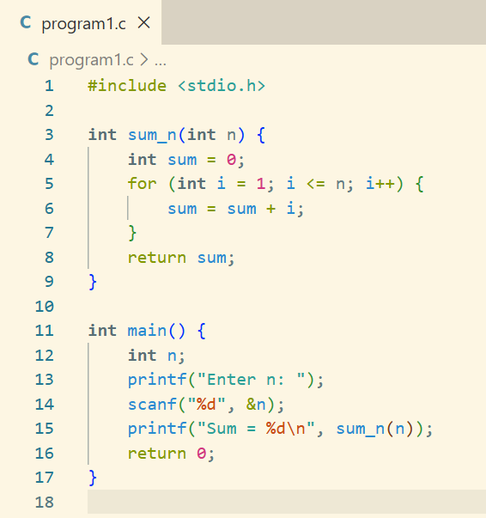
Output: 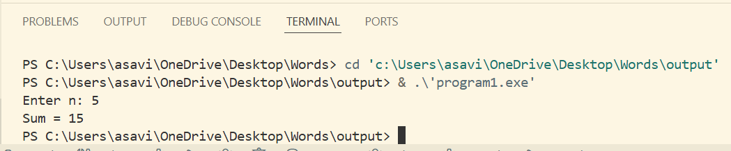
Complexity:
Loop runs from 1 to n → Time: O(n).
Only a few int variables are used → Space: O(1).

2️⃣ Sum of squares of first n natural numbers
Code: 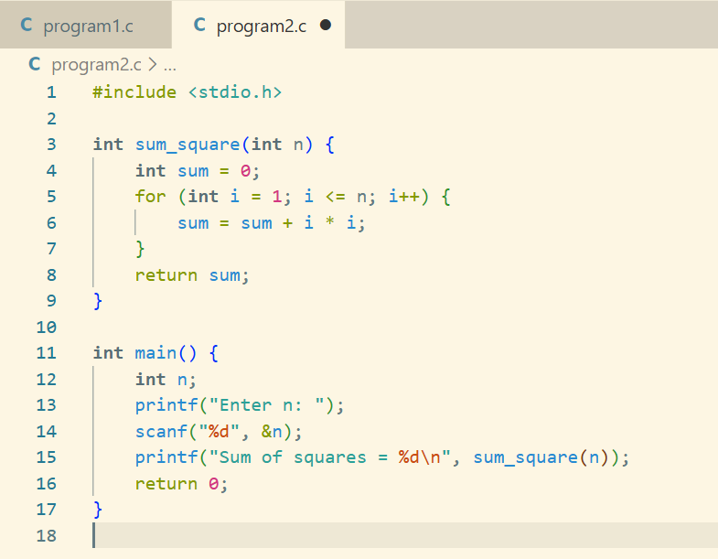
Output: 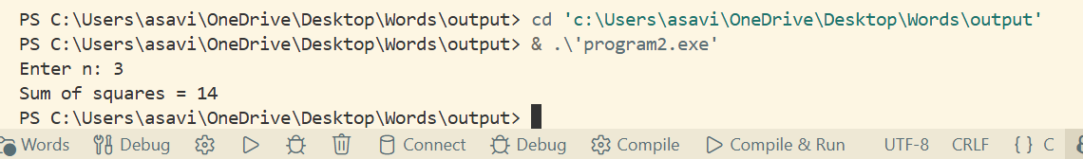Complexity:
One loop till n doing constant work each time → Time: O(n), Space: O(1).

3️⃣ Sum of cubes of first n natural numbers
Code:
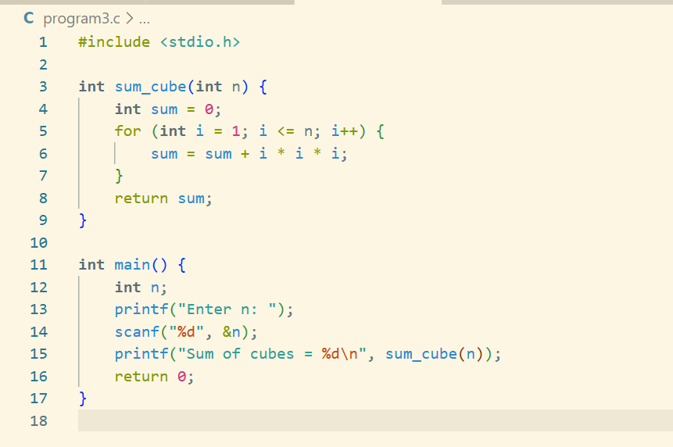
Output:
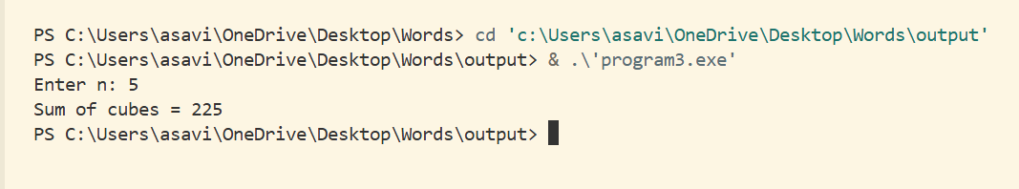
Complexity:
a single loop from 1 to n → Time: O(n), with constant extra variables → Space: O(1)

4️⃣ Factorial of a number using recursion
Code: 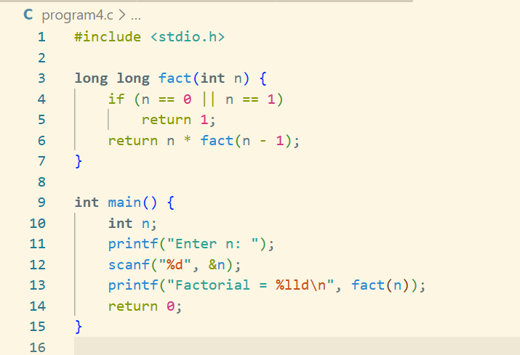
Output:
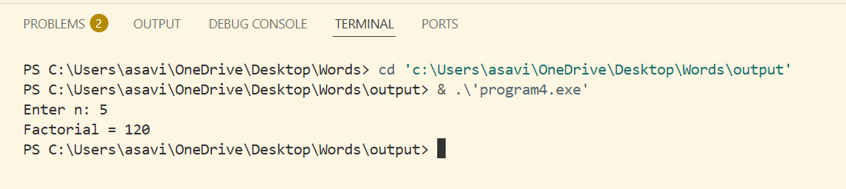
Compexity:
Function calls itself n times → Time: O(n).
Each call stays on the call stack → Space: O(n) (stack space).

5️⃣ Transpose of a 3×3 matrix
Code:
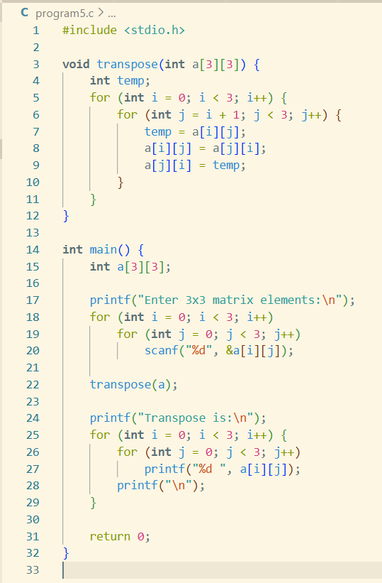
Output:
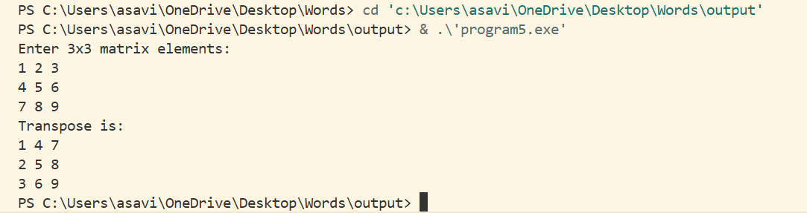
Compexity:
We touch each element once (for general n×n matrix that’s n² elements) → Time: O(n²).
We only use one temporary variable and do swaps in-place → Space: O(1).

6️⃣ Fibonacci series
Code:
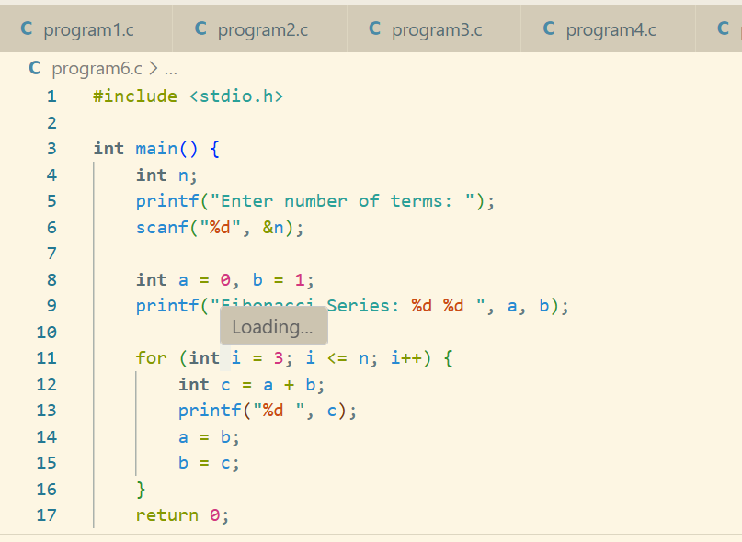
Output:
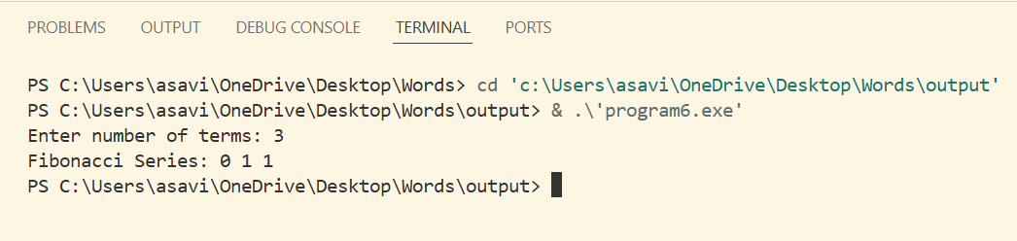
Complexity:
Time Complexity
O(n)
Because we run one loop from 3 to n.
Space Complexity
O(1)
We use only 3 variables (a, b, c) → constant space.

